5_Configure and verify path control using PBR (Policy Based Routing).

Aim: Configure and verify path control using PBR (Policy Based Routing).

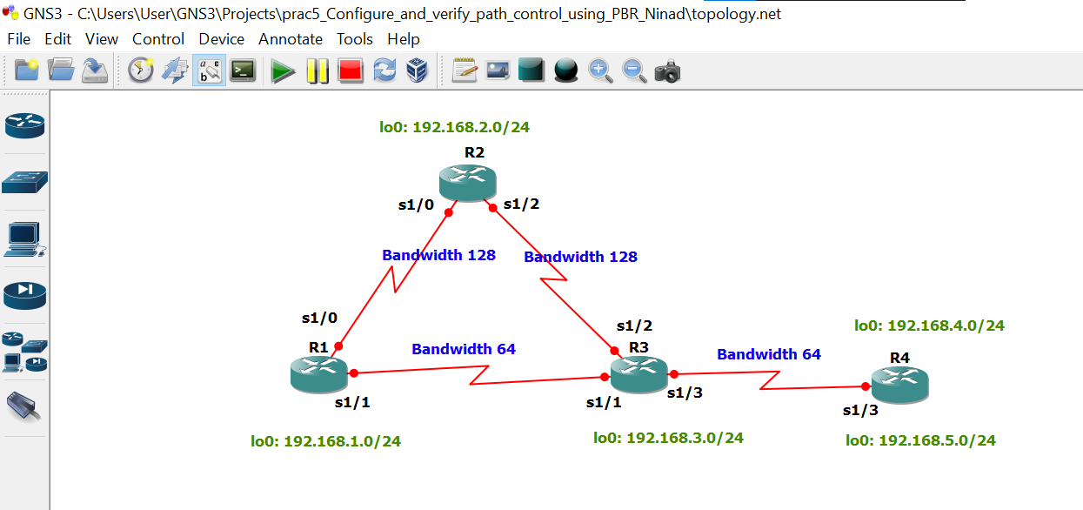
Take 4 routers -> Configure -> slots -> NM-4T
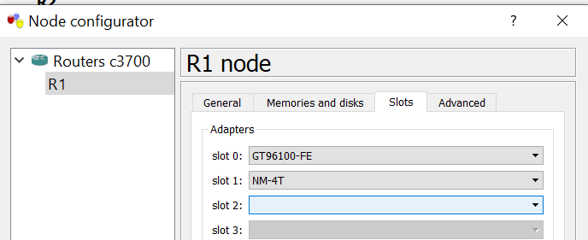

STEP 1: Perform IP configuration
On router 1 console

R1 # conf t
R1(config) # hostname r1
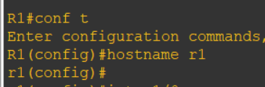
r1(config) # int s1/0
r1(config-if) # ip add 172.16.12.1 255.255.255.0
r1(config-if) # bandwidth 128
r1(config-if) # no sh
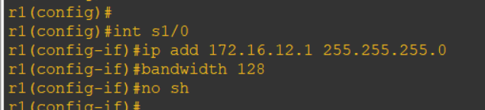
r1(config-if) # int s1/1
r1(config-if) # ip add 172.16.13.1 255.255.255.0
r1(config-if) # bandwidth 64
r1(config-if) # no sh
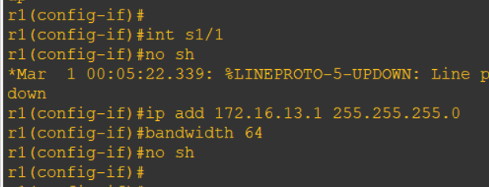
r1(config-if) # int lo0
r1(config-if) # ip add 192.168.1.1 255.255.255.0

r1(config-if) # do sh ip int br | include up

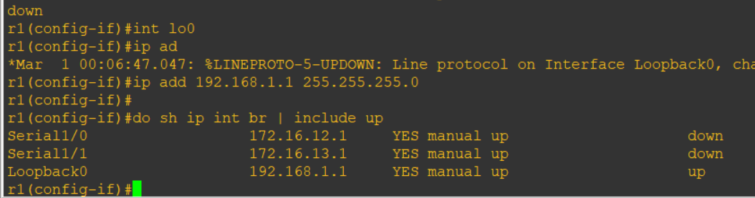

On router 2 console
R2 # conf t
R2(config) # hostname r2
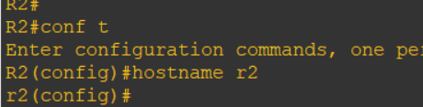
r2(config) #
r2(config) # int s1/0
r2(config-if) # ip add 172.16.12.2 255.255.255.0
r2(config-if) # bandwidth 128
r2(config-if) # no sh
r2(config-if) #
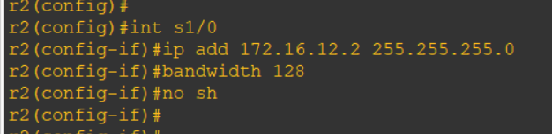
r2(config-if) # int s1/2
r2(config-if) # ip add 172.16.23.2 255.255.255.0
r2(config-if) # bandwidth 128
r2(config-if) # no sh
r2(config-if) #
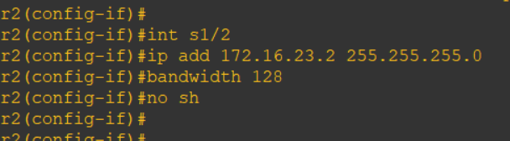
r2(config-if) # int lo0
r2(config-if) # ip add 192.168.2.2 255.255.255.0
r2(config-if) #
r2(config-if) # do sh ip int br | include up

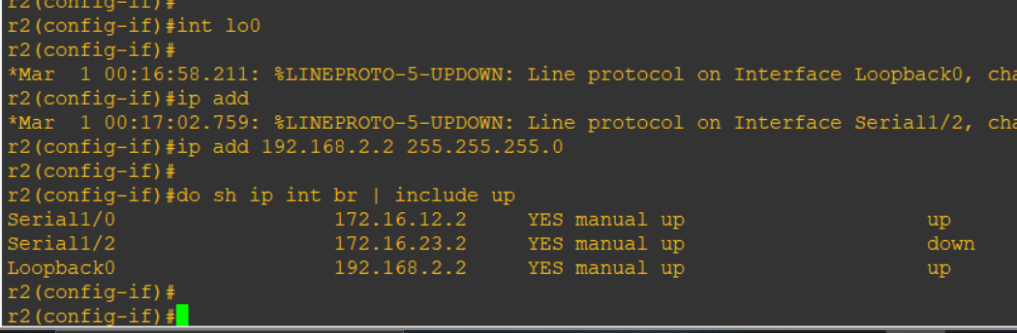

On router 3 console

R3 # conf t
R3(config) # hostname r3
r3(config) #
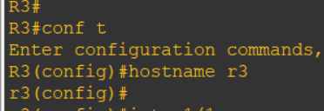

r3(config) # int s1/1
r3(config-if) # ip add 172.16.13.3 255.255.255.0
r3(config-if) # bandwidth 64
r3(config-if) # no sh
r3(config-if) #
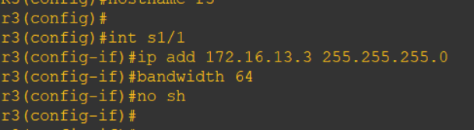

r3(config-if) # int s1/2
r3(config-if) # ip add 172.16.23.3 255.255.255.0
r3(config-if) # bandwidth 128
r3(config-if) # no sh
r3(config-if) #
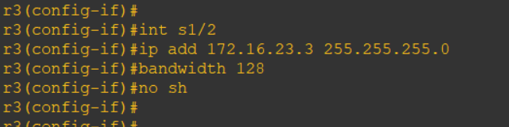

r3(config-if) # int s1/3
r3(config-if) # ip add 172.16.34.3 255.255.255.0
r3(config-if) # bandwidth 64
r3(config-if) # no sh
r3(config-if) # 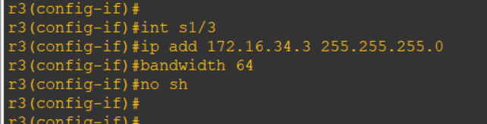

r3(config-if) # int lo0
r3(config-if) # ip add 192.168.3.3 255.255.255.0
r3(config-if) #
r3(config-if) # do sh ip int br | include up
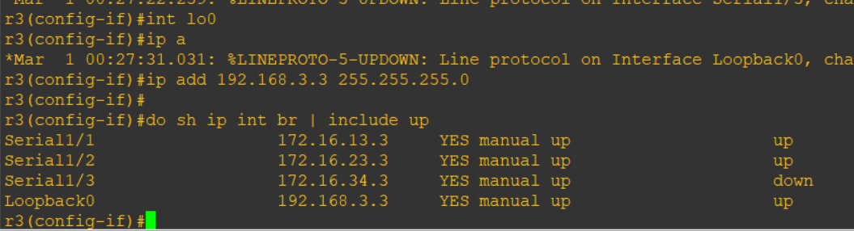

On router 4 console
R4 # conf t
Enter configuration commands, one per line. End with CNTL/Z.
R4(config) # hostname r4
r4(config) #
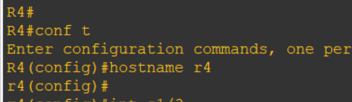

r4(config) # int s1/3
r4(config-if) # ip add 172.16.34.4 255.255.255.0
r4(config-if) # bandwidth 64
r4(config-if) # no sh
r4(config-if) #
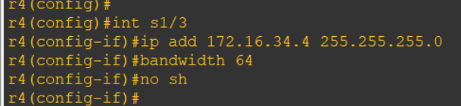

r4(config-if) # int lo0
r4(config-if) # ip add 192.168.4.1 255.255.255.0
r4(config-if) #
r4(config-if) # int lo1
r4(config-if) # ip add 192.168.4.1 255.255.255.0
r4(config-if) # ip add 192.168.5.1 255.255.255.0
r4(config-if) #
r4(config-if) # do sh ip int br | include up
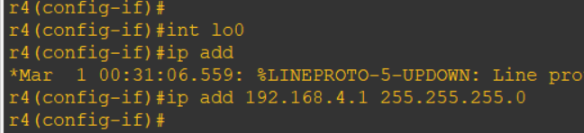
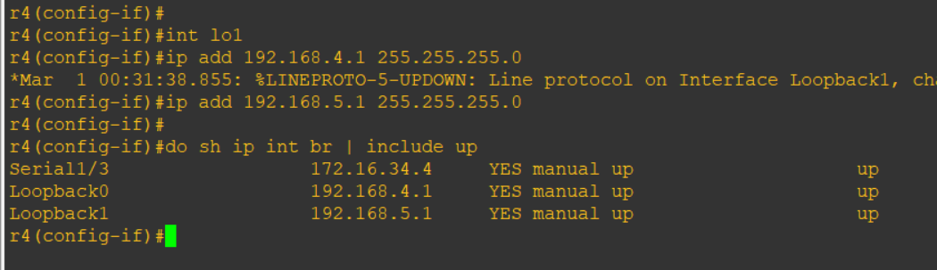

STEP 2 : Configure eigrp on all routers
On router 1 console

r1(config) # router eigrp 1
r1(config-router) # network 172.16.12.0 0.0.0.255
r1(config-router) # network 172.16.13.0 0.0.0.255
r1(config-router) # network 192.168.1.0
r1(config-router) # no auto-summary
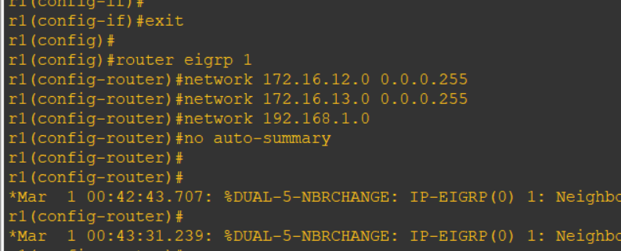

On router 2 console
r2(config) # router eigrp 1
r2(config-router) # network 172.16.12.0 0.0.0.255
r2(config-router) #
r2(config-router) # network 172.16.23.0 0.0.0.255
r2(config-router) # network 192.168.2.0
r2(config-router) # no auto-summary
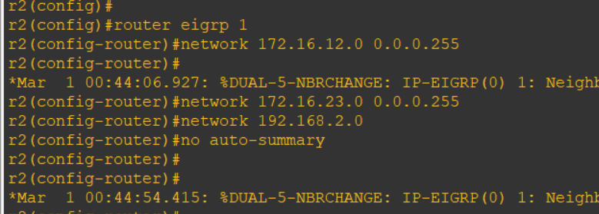

On router 3 console
r3(config-if) # router eigrp 1
r3(config-router) # network 172.16.13.0 0.0.0.255
r3(config-router) # network 172.16.13.0 0.0.0.255
r3(config-router) # network 172.16.23.0 0.0.0.255
r3(config-router) # network 172.16.34.0 0.0.0.255
r3(config-router) # network 192.168.3.0
r3(config-router) # no auto-summary
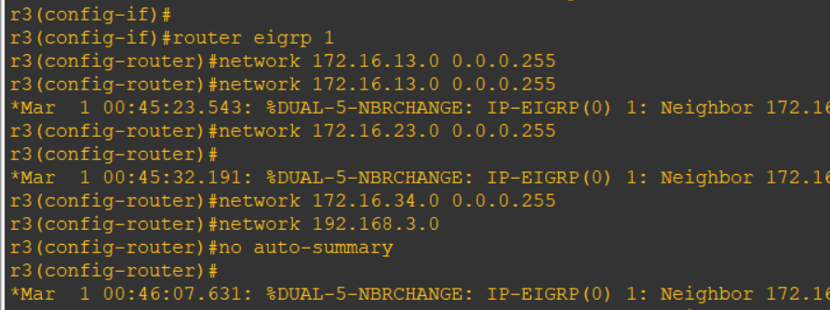

On router 4 console
r4(config) # router eigrp 1
r4(config-router) # network 172.16.34.0 0.0.0.255
r4(config-router) #
r4(config-router) # network 192.168.4.0
r4(config-router) # network 192.168.5.0
r4(config-router) # no auto-summary
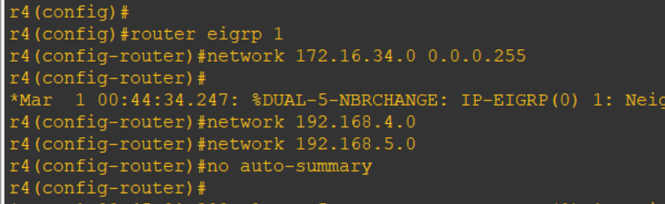

STEP 3: Command on all routers
do sh ip route

r4(config) # do ping 192.168.1.1
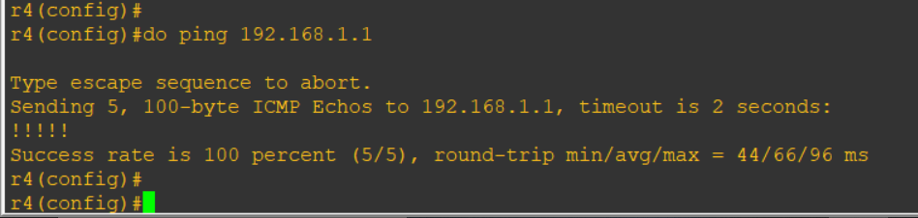
r1(config) # do ping 192.168.4.1
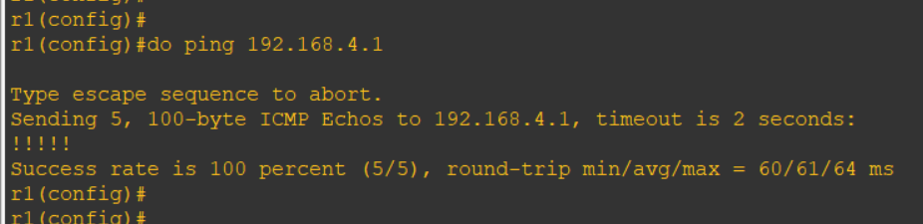

R4
r4(config) # do traceroute 192.168.1.1 source 192.168.4.1
r4(config) #
r4(config) # do traceroute 192.168.1.1 source 192.168.5.1
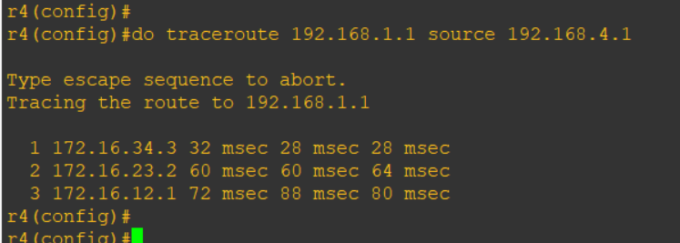
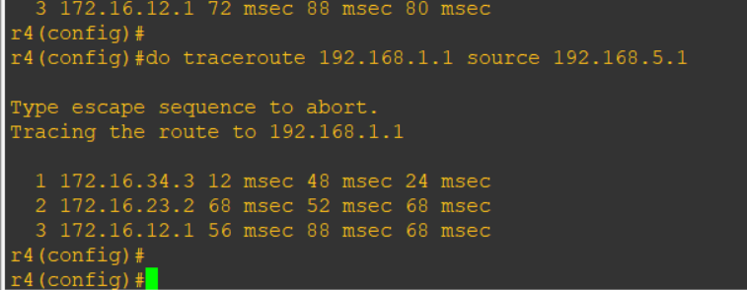
Configure PBR to provide path control
- All traffic from source 192.168.5.1 should take route R4 -> R3 -> R1
- All traffic from source 192.168.4.1 should take route R4 -> R3 -> R2 -> R1
On router 3 console
r3(config) # ip access-list standard pbr-acl
r3(config-std-nacl) # permit 192.168.5.0 0.0.0.255
r3(config-std-nacl) # exit
r3(config) #
r3(config) #
r3(config) # route-map r3-to-r1 permit
r3(config-route-map) # match ip address pbr-acl
r3(config-route-map) #
r3(config-route-map) # set ip next-hop 172.16.13.1
r3(config-route-map) # exit
r3(config) #
r3(config) # int s1/3
r3(config-if) # ip policy route-map r3-to-r1
r3(config-if) # end
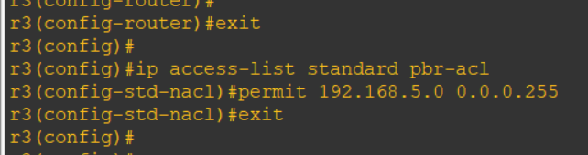
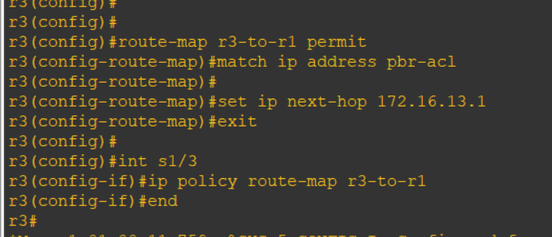

On router 4 console
r4(config) # do traceroute 192.168.1.1 source 192.168.4.1
r4(config) # do traceroute 192.168.1.1 source 192.168.5.1

